Self-Declaration of the Certification Body
- We hereby undertake to carry out certification activities in compliance with all applicable laws and regulations.
- We adhere to the principles of objectivity and independence, and firmly oppose any form of unfair competition.
- All certification decisions shall be made free from any commercial, financial, or other undue influence.
- We shall not engage in any paid consulting activities that may compromise the impartiality of certification.
- We resolutely oppose and reject any practices that disrupt market order, including but not limited to false certification, buying and selling of certificates, and malicious price undercutting.
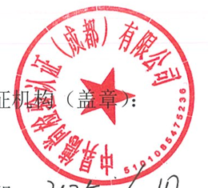
- We fully commit to disclosing information as required, and accept public supervision.
- We proactively assume primary responsibility and strive to uphold the credibility and integrity of the certification industry.
Legal Representative(Signature): Certification Body(Seal):
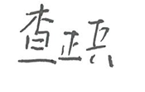
Date:2025.6.10

